Read the data from JSON and provide a command/value to avoid inconvenience or issues in the core program.

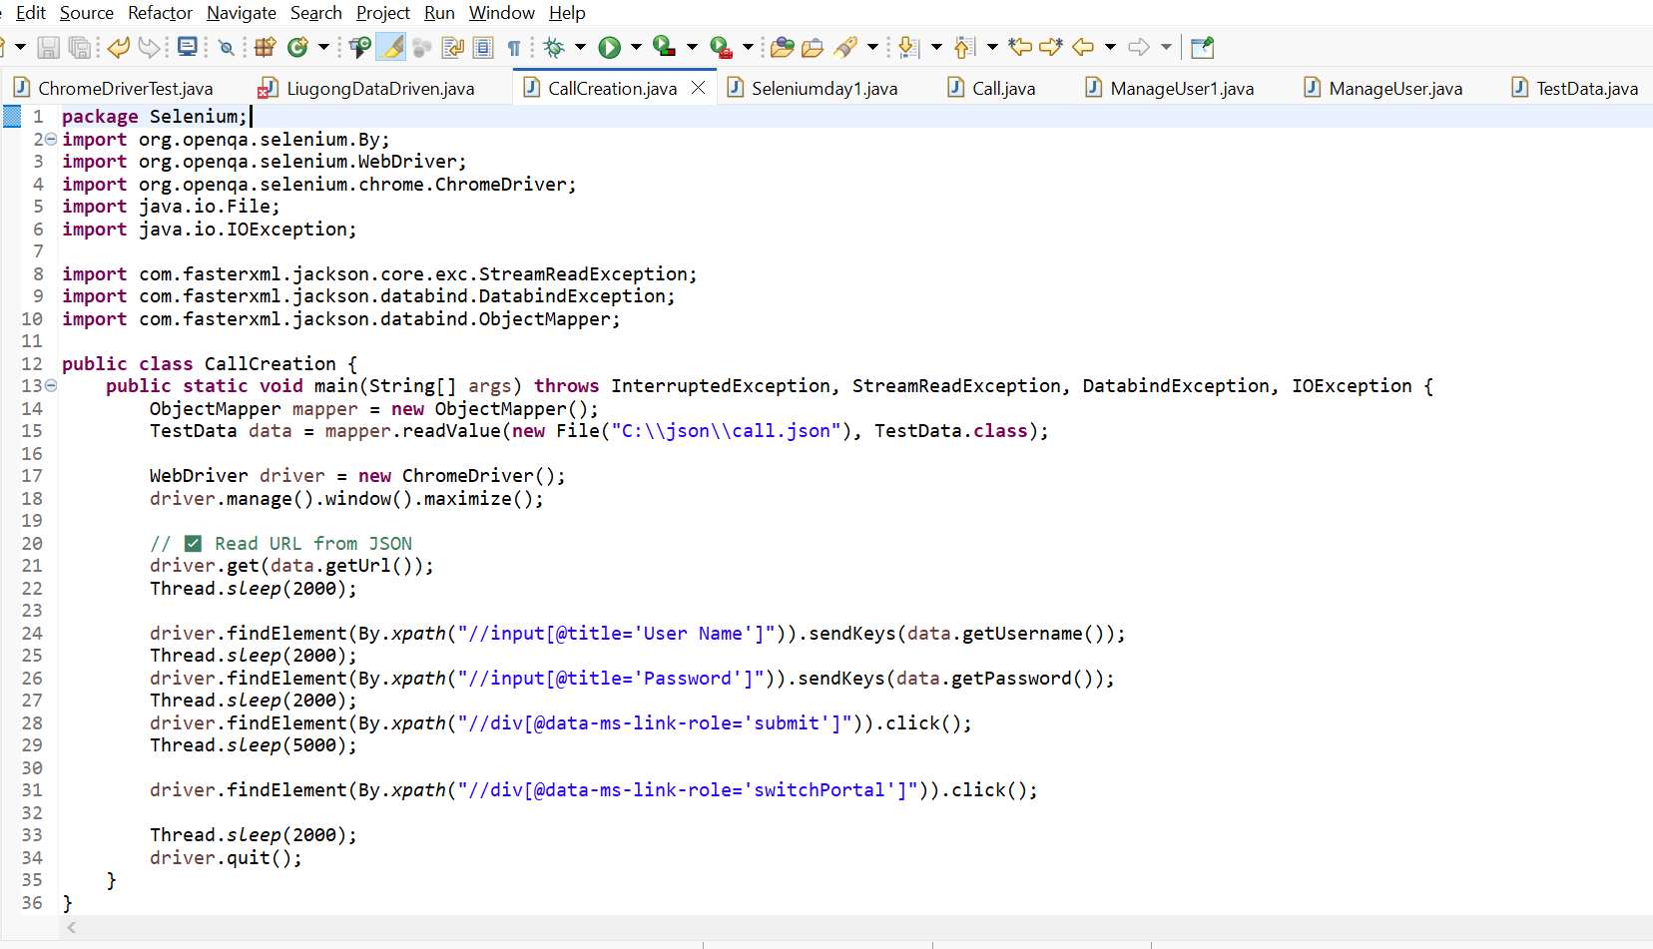
This code includes the path of a JSON file, reads the data from the JSON folder, and provides a common name.

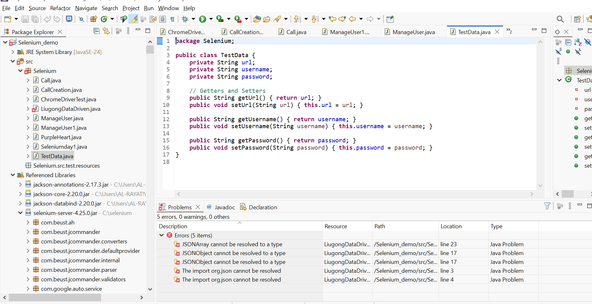
This is the core data setup provided with a common name to run.

This is the path ill create in Json.
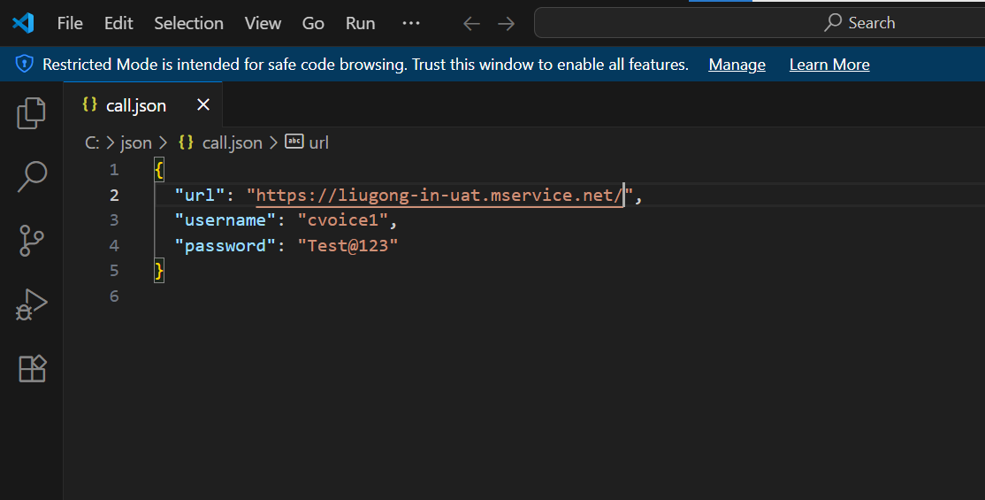

It just a beginning , ill try more effective in upcoming days.
Basic Data Types in JSON
- String → "Hello World"
- Number → 123, 45.67
- Boolean → true / false
- Null → null
- Object → { "key": "value" }
- Array → [1, 2, 3]
Why Use JSON in Automation
- To store test data (like username, password, URLs, etc.).
- To keep data separate from code (easy to maintain).
- To support multiple environments (DEV, UAT, PROD).
- To handle dynamic test inputs.
JSON (JavaScript Object Notation) is a lightweight data-interchange format.
- It is easy to read and write for humans.
- It is easy to parse and generate for machines.
- Commonly used to exchange data between a server and a client.

Architecture of working
Json
server
Client

14+ programming Browser Driver
Request
Request

Response
Response

Selenium is a Third part tool so it does not accept directly , se we need browser drivers

